Udon Noodle Soup with Wasabi & Ginger Lamb Balls
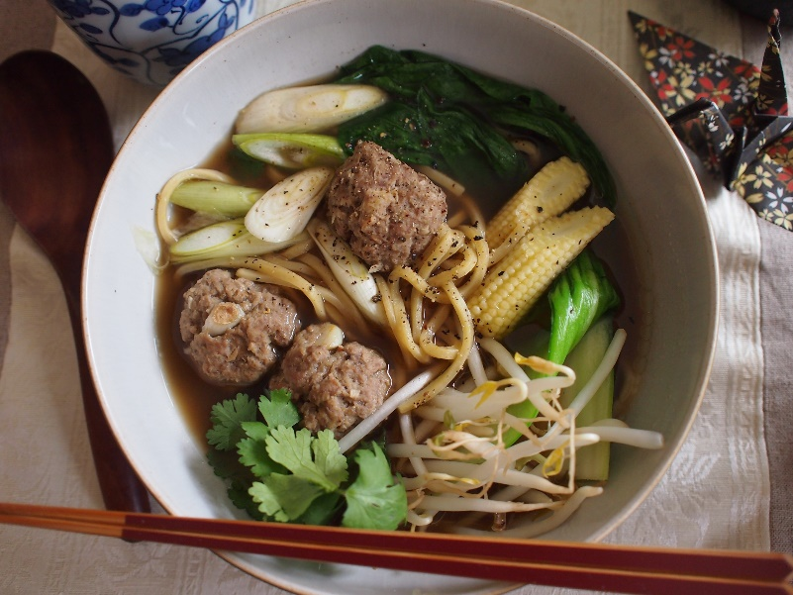
<Ingredients (1 serve)>
<For lamb ball>
- 2.5 oz Lamb, minced
- 1 Tbsp Ginger, grated
- 1 tsp Garlic, grated
- 1 Tbsp Wasabi Paste
- A pinch of Sea Salt
- 1 tsp Soy Sauce

<For Soup>
- 2/3 cup Seafood Stock
- 1 Tbsp Soy Sauce
- 2 tsp Sake
- 2 pinch Sea Salt
- 3/4 stalk Fresh Cilantro
- 1 portion Udon Noodles

<For topping>
- Bok Choi (ends trimmed and boiled)
- 2 stalks Fresh Cilantro
- Scallion, chopped
- Bean Sprout
- Baby Corn, boiled

<Method>
1. Make a soup
- Put the seafood stock and cilantro in a small pot and bring to boil.
- Keep simmering until the flavor of cilantro is infused into the soup.
- Remove the cilantro from the soup and add the soy sauce, sake and sea salt. Bring to boil.
- Turn off the heat and set it aside.

2. Make lamb balls
- Put all ingredients in a bowl and combine well until the mixture turns into sticky using your hand.
- Firmly shape the mixture into 3 to 4 even-sized balls.
- Bring the soup to a boil again, and place the lamb balls into the soup and simmer for 3 minutes.
- Boil the Udon noodle al dente.

3. Assemble the soup noodle
- Place the noodle and lamb balls into the bowl and pour over the soup.
- Put the toppings and serve immediately.

<Tips for cooking>
#1. Sticky mixture
Mix the lamb mince well until the mixture is enough sticky to make a ball shape.

#2. Flavourful soup
Udon noodle is thick, so it’s better to season the soup a little bit more flavourful and savoury.

